# UNITED KINGDOM

The [OECD Regional Outlook](https://www.oecd-ilibrary.org/urban-rural-and-regional-development/oecd-regional-outlook_2dafc8cf-en) reviews recent trends, policy developments, and prospects across OECD regions, including the underlying causes driving regional inequalities in performance and well-being. The report offers evidence, guidance and policy recommendations on how to improve competitiveness and productivity, promote inclusive growth, accelerate the net-zero transition and raise well-being standards through effective regional development policy and multi-level governance.

## Territorial definitions

The data in this note reflect different sub-national geographic levels in OECD countries. In particular, **regions** are classified on two territorial levels reflecting the administrative organisation of countries: large regions (TL2) and small regions (TL3). In Canada, TL2 corresponds to the provinces and territories.

Small regions are classified according to their access to metropolitan areas (Fadic et al. 2019). The typology classifies small (TL3) regions into metropolitan and non-metropolitan regions according to the following criteria:

* **Metropolitan regions**, if more than half of the population live in a FUA. Metropolitan regions are further classified into **metropolitan large**, if more than half of the population live in a (large) FUA of at least 1.5 million inhabitants; and **metropolitan midsize**, if more than half of the population live in a (midsize) FUA of at 250 000 to 1.5 million inhabitants.
* **Non-metropolitan regions**, if less than half of the population live in a midsize/large FUA. These regions are further classified according to their level of access to FUAs of different sizes: **near a midsize/large FUA** if more than half of the population live within a 60-minute drive from a midsize/large FUA (of more than 250 000 inhabitants) or if the TL3 region contains more than 80% of the area of a midsize/large FUA; **near a small FUA** if the region does not have access to a midsize/large FUA and at least half of its population have access to a small FUA (i.e. between 50 000 and 250 000 inhabitants) within a 60-minute drive, or contains 80% of the area of a small FUA; and **remote**, otherwise.

Disclaimer: <https://oecdcode.org/disclaimers/territories.html>

Overview

|  |  |  |
| --- | --- | --- |
| Population *(specify date)* and territory | UF: 67,026,000 (mid 2021) UK: 248,848 sq km | |
| Administrative structure *(unitary/federal)* | Unitary | |
| Regional or state-level governments *(number)* | Three Devolved Administrations: Wales, Scotland, Northern Ireland | |
| Intermediate-level governments *(number)* | 10 Mayoral Combined Authorities (MCAs) including Greater London Council | |
| Municipal-level governments *(number)* | 333 local authorities in England; 32 local authorities in Scotland, 22 in Wales and 11 in Northern Ireland. | |
| Share of subnational government in total expenditure/revenues (2021) | 20.7% of total expenditure  25.2% of total revenues  [Source: [Subnational governments in OECD countries: key data, 2023 edition](https://stats.oecd.org/Index.aspx?DataSetCode=SNGF)] | |
| Key regional development challenges | * Deep regional economic and social inequality which is the legacy of a long period of rapid productivity growth in London and South-East England and rapid deindustrialization in poorer regions of the country. * Rising inflationary pressures and slow national economic growth are challenging an already fragile recovery from Covid 19 and the impact of the war in Ukraine, with implications for regional development and delivering the UK Government’s Levelling Up objectives. | |
| Objectives of regional policy | Main objectives of UK Government’s Levelling Up policy (see Levelling Up White Paper 2022) are:   1. Boosting productivity, pay, jobs and living standards by growing the private sector, especially in those places where they are lagging 2. Spreading opportunities and improving public services, especially in those places where they are weakest 3. Restoring a sense of community, local pride and belonging, especially in those places where they have been lost 4. Empowering local leaders and communities, especially in those places lacking local agency.   The UK Government, under its Levelling Up policy, has also set 12 clear and ambitious medium-term missions that are spatially targeted, measurable and time-bound objectives to improve the situation in the places that need support the most. | |
| Legal/institutional framework for regional policy | * Local Democracy, Economic Development and Construction Act 2009 - established powers to enable two or more local authorities to collaborate and take decisions across council boundaries. * Local Growth: Realising Every Place’s Potential White Paper 2010 – led to the creation of Local Enterprise Partnerships (LEPs) * Cities and Local Government Devolution Act 2016 * Scotland Act 2016 – gave additional powers to the Scottish Government. * Levelling Up White Paper 2022 - policy document setting out the UK Government’s ‘levelling up’ policy. * Levelling-up and Regeneration Bill 2023 – a wide ranging bill that makes provision for more devolution, the setting of 12 levelling up missions and reporting on progress in delivering them, and introduction of a new Community Infrastructure Levy. | |
| Budget allocated to regional development (i.e., amount) and fiscal equalisation mechanisms between jurisdictions (if any) | * UK Shared Prosperity Fund 2022 - £2.6 billion – replaced EU Structural Funds following UK departure from the EU. * Barnett Formula - a mechanism used in the UK to automatically adjust the amounts of public expenditure allocated to Northern Ireland, Scotland, and Wales to reflect changes in spending levels allocated to public services in England. | |
| National regional development policy framework | * The Levelling Up White Paper launched in 2022 sets out the UK Government’s policies and objectives to address regional economic and social inequalities in the UK, including the Devolved Administrations. | |
| Urban policy framework | * City Deals Policy – in 1st wave 26 City Deals agreed in England 2012-2014, and one in Scotland. Since 2014, 5 further City Deals agreed in Scotland, two in Wales and one in Northern Ireland. Two further City Deals in Northern Ireland to be agreed. * Devolution Policy - transfer of powers and funding from national to local government, including city regions (Mayoral Combined Authorities).and County Deals. * Towns Fund 2021 - £3.6 billion fund for struggling towns across England. * Town Deals 2021 – 101 towns benefitting from the Towns Fund * Future High Streets Fund 2019 - £675m fund to renew town centres and high streets * Levelling Up White Paper 2022 – policy document setting out the UK Government’s ‘levelling up’ policy. * Deep Dive Partnerships 2022– 3 pilot places (Blackpool, Blyth, Grimsby) selected for initial levelling up partnerships * Levelling Up Partnerships 2023 - £400m fund to help 20 poorly performing places. * National Planning Policy Framework (NPPF) – sets out government spatial planning policies for England and how they’re expected to be delivered at a local level. | |
| Rural policy framework | * Levelling Up White Paper 2022 – see above. * Rural Proofing: Practical Guidance to Assess Impacts of Policies on Rural Areas – issued 2017, updated 2022 * Delivering for Rural England – the 2nd Report on Rural Proofing * Rural England Prosperity Fund 2022 - £110m fund for small businesses and community infrastructure in rural areas * UK Government Food Strategy 2022 | |
| Major regional policy tools (e.g., funds, plans, policy initiatives, institutional agreements, etc.) | | * European Structural and Investment Funds (ESIF) 2014-20 – delivering funding to end 2023. Closed for new applications. * Local Growth Fund 2020-2023 – over £12 billion awarded to LEPs to support economic growth and jobs across England. * Getting Building Fund 2020 - £900 million fund to support mayors and LEPs to deliver jobs, skills and investment. * Levelling Up Fund (LUF) 2021 - £4.8 billion fund to invest in local infrastructure and support economic recovery across the UK. * Towns Fund 2021- £3.6 billion fund to assist struggling towns. * UK Community Renewal Fund (CRF) 2021 - £125m fund to support pilot projects to prepare for the UK Shared Prosperity Fund * UK Shared Prosperity Fund (UKSPF) 2022 - £2.6 billion fund to replace EU Structural Funds following UK departure from the EU. * Community Ownership Fund (COF) - £150 million UK-wide fund to support community groups to take over treasured local assets. * Levelling Up Policy 2022 – see Levelling Up White Paper. * Local Skills Improvement Plans (LSIPs) 2022 – employer-led initiative to improve skills training in England and close skills gaps. * Devolution Deals – transfer of powers and funding from national to local government through programme of bespoke deals. * Deeper Devolution Deals announced for Greater Manchester and West Midlands 2023 – more planned. * Enterprise Zones (EZs) – 45 EZs launched in England since 2012 * Investment Zones (IZs) – 12 announced in England in 2023 to drive investment and level up the country. * Freeports – 8 Freeports announced in England, 2 in Wales and 2 in Scotland since 2021. |
| Policy co-ordination tools at national level | * A Levelling Up Cabinet Committee has been established to embed levelling up across central government policy design and delivery. It works directly with local leaders to improve the clarity, consistency and coordination of policy. * The Department for Levelling Up, Housing and Communities (DLUHC) works across central government to deliver the objectives of the Levelling Up White Paper. * A new external Levelling Up Advisory Council to support Ministers by advising on the design, delivery and impact of levelling up policy. * A new statutory duty to publish an annual report analysing progress on levelling up is being introduced in the Regeneration and Levelling Up Bill 2023. * Joint Area Teams of officials from the Department for Levelling Up, Housing and Communities (DLUHC) and Department for Business and Trade (DBT) in different parts of the country work across government departments and with LEPs and local authorities to support and deliver policy at a local level. | |
| Multi-level governance mechanisms between national and subnational levels (e.g., institutional agreements, Committees, etc.) | * As part of devolution policy national government works regularly with LEPs and local authorities through a number of bodies: * the M10 Group of Mayoral Combined Authorities meets regularly with central government officials to discuss progress on devolution and levelling up policy: * the Local Government Association (LGA) represents most local councils in England and meets regularly with central government officials/ Ministers to discuss issues affecting local authorities in England, including annual funding allocations. * The Local Enterprise Partnership (LEP) Network represents all 38 LEPs in England and champions their role in building local economic growth and jobs. Meets regularly with central government officials and acts as a key negotiator for LEPs. * Area Teams of DLUHC and DBT officials across the UK provide a channel of communication between national government and local and combined authorities in England on national, regional and local issues. * Pan Regional; Partnerships (PRPs) – coordinate activities with their member local authorities and national government at a sub-regional and sub national level. * Core Cities Group – advocacy group of 11 major UK regional cities (excluding London) – meets with central government officials on national and regional issues. * Devolution Deals with local and combined authorities involve regular meetings between national and local government officials during individual deal negotiations. | |
| Policy co-ordination tools at regional level | * A series of pan regional partnerships (PRPs) have been established to co-ordinate activity with their member local authorities and national Government. They follow from the recognition of the importance of building economic and infrastructure strategy around functional economic areas, both at a sub-regional and subnational level. These PRPs include the Northern Powerhouse, the Midlands Engine, Oxford-Cambridge Corridor, Western Gateway, the Thames Estuary Growth Board. | |
| Evaluation and monitoring tools | * The UK Office for National Statistics’ Subnational Data Strategy aims to improve the UK’s sub national data, mapping local; economic geographies and helping to improve transparency and accountability to the public. * New interactive tools and maps are being developed to facilitate this process to encourage innovative uses of real-time data at a local level, giving local leaders the information they need to deliver. * The 12 levelling up missions in the Levelling Up White Paper are being monitored and evaluated at national level by a team of analysts in the Department for Levelling Up, Housing & Communities. | |
| Future orientations of regional policy | * The UK government is committed to devolution across England by setting itself a mission that, by 2030, every part of England that wants one will have a devolution deal, with powers at or approaching the highest level of devolution. * Devolution will be extended by: * entering formal negotiations to agree new devolution deals with more areas of England, either as Mayoral Combined Authorities or County Deals at county level; and encouraging other areas to consider these models. Devolution is seen as an important tool to support regional/ sub regional and local growth. * deepening devolution by holding trailblazer deals with the West Midlands and Greater Manchester (now agreed) to act as the blueprint for other Mayoral Combined Authorities to follow. * working with Mayoral Combined Authorities, initially as part of the trailblazer deals, to explore options to streamline the funding landscape for Mayoral Combined Authorities. * inviting other Mayoral Combined Authorities and the Greater London Authority to bid for sweeping further powers, through the new devolution framework. | |

## Regional Inequality Trends

The United Kingdom experienced an increase in the Theil index of GDP per capita over 2000-2020. Inequality reached its maximum in 2015. The figures are normalized, with values in the year 2000 set to 1.

The Top 20%/Mean ratio was 0.061 higher in 2020 compared to 2000, indicating increased polarisation. The Bottom 20%/Mean ratio did not change in the same period.

**Figure 1. Trends in GDP per capita inequality indicators, TL3 OECD regions**

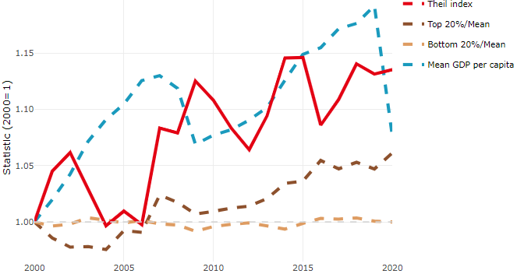

**Note**: Top/bottom calculated as population equivalent (top/bottom regions with at least 20% of the population). The interpretation of top/bottom 20% GDP per capita is that 20% of the population in the country holds 20% of the value. Top 20%/Mean calculated as mean GDP per capita in top 20% regions over mean TL3 GDP per capita in a given year. Bottom 20%/Mean calculated as mean TL3 GDP per capita in bottom 20% regions over mean TL3 GDP per capita in a given year. To improve data consistency, input series are aggregated when TL3 regions are part of the same FUA. To improve time series, TL3 missing values have been estimated based on the evolution at higher geographic level.

**Source**: OECD Regional Database (2022).

In 2020, the gap in GDP per capita between large metropolitan and non-large metropolitan regions was 1.078. For reference, the same value for OECD was 1.475. This gap increased by 0.035 percentage points between 2000 and 2020.

Meanwhile, in 2020, the gap in GDP per capita between metropolitan and non-metropolitan regions was 1.111. For reference, the same value for OECD was 1.325. This gap increased by 0.069 percentage points since 2000.

In turn, the gap in GDP per capita between regions near and far a Functional Urban Area (FUA) of more than 250 thousand inhabitants was 1.16 in 2020 and decreased by 0.031 percentage points since 2000.

**Figure 2. GDP per capita gap by type of region compared to the OECD average**

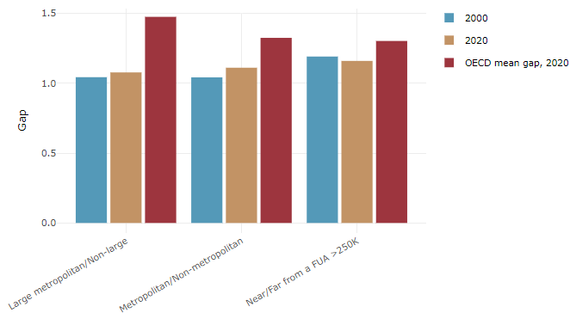

**Note**: Far from a FUA>250K includes regions near/with a small FUA and remote regions. OECD mean gap based on 1 586 TL3 regions in 27 countries with available data (no TL3 data for Australia, Canada, Chile, Colombia, Costa Rica, Iceland, Ireland, Israel, Mexico, Luxembourg and Switzerland).

**Source**: OECD Regional Database (2022).

In the United Kingdom, the gap between the upper and the lower half of regions in terms of labour productivity increased between 2004 and 2019. Over this period labour productivity in the upper half of regions grew roughly by 10%, 3 percentage points more than in the lower half of regions. During 2020, the gap narrowed down. Nevertheless, more years of data are necessary to determine the long-term impact of the COVID-19 pandemic on labour productivity gaps in regions.

**Figure 3. Evolution of labour productivity, TL3 OECD regions**

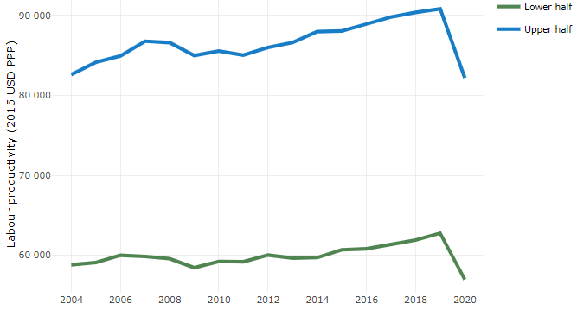

**Note**: A region is in the “upper half” if labour productivity was above the country median in the first year with available data and “lower half” if productivity was below the country median. Labour productivity in each group is equal to the sum of Gross Value Added, expressed in USD at constant prices and PPP (base year 2015) within the group, divided by the sum of total employment in regions within the group. Regions are small (TL3) regions, except for Australia, Canada, Chile, Colombia, Ireland, Mexico, Norway, Switzerland, Türkiye and the United States where they are large (TL2) regions due to data availability.

**Source**: OECD Regional Database (2022).

Regions where the economic activity shifts towards tradable activities, such as industry and tradable services, tend to grow faster in terms of labour productivity. In the United Kingdom, between 2004 and 2020, the share of workers in the industrial sector went down in all regions, approximately by the same amount. At the same time, the share of workers in the tradable services sector went up in all regions but more so in regions that used to be in the lower half of the labour productivity distribution. Hence, the evolution of employment shares in the tradable services sector reduced the labour productivity gap between regions.

**Figure 4. Share of workers in most productive (tradable) sectors, TL3 OECD regions**

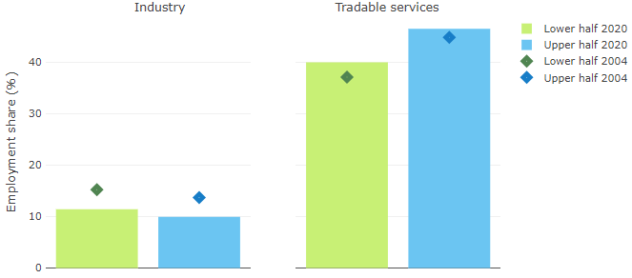

**Note**: A region is in the “upper half” if labour productivity was above the country median in the first year with available data and “lower half” if productivity was below the country median. The share of workers in a given sector for a group of regions is defined as the sum of employment in that sector within the group divided by the sum of total employment within the group. Regions are small (TL3) regions, except for Australia, Canada, Chile, Ireland, Mexico, Norway, Switzerland, Türkiye and the United States where they are large (TL2) regions due to data availability. Industry includes the following tradable goods sectors: Mining and quarrying (B), Manufacturing (C), Electricity, gas, steam and air conditioning supply (D) and Water supply; sewerage; waste management and remediation activities (E) NACE macro sectors. Tradable services include Information and communication (J), Financial and insurance activities (K), Real estate activities (L), Professional, scientific and technical activities (M), Administrative and support service activities (N).

**Source**: OECD Regional Database (2022).

## Recent policy developments

There is no explicit regional development policy framework since the Regional Development Agencies in England were closed in 2010. However, since 2011 the UK Government has shifted its focus in England to functional economic areas by launching Local Enterprise Partnerships, of which there are currently 38, to bring together businesses and local leaders to drive economic growth across England and deliver some government programmes including the Local Growth Fund, Getting Building Fund and programmes linked to skills development. The three Devolved Administrations in Wales, Scotland and Northern Ireland have responsibility for urban, regional and spatial planning policies in their areas, but the UK Government has established offices in all three territories to help deliver UK wide levelling-up programmes such as the Levelling Up Fund, UK Shared Prosperity Fund and Communities Opportunities Fund, among other initiatives.

With the launch of the Levelling Up White Paper in 2022, there has been an enhanced programme of spreading opportunity to all parts of the country and the three Devolved Administrations in Wales, Scotland and Northern Ireland. Since 2011, in England the government has shifted focus in England to functional economic areas by launching Local Enterprise Partnerships and has pursued a policy of devolving more power and resources to local and combined authorities such as Mayoral Combined Authorities and Combined County Authorities.

Devolution is at the heart of the UK Government’s plans to increase economic growth and level up the whole country. The Government announced the biggest ever transfer of powers away from Westminster in the Levelling Up White Paper. It is committed to further extending devolution across England and seeing more empowered and accountable local leaders who can drive growth, innovate, and respond to the specific challenges and needs of their areas. Six new devolution deals were announced in 2022 to drive forward improved outcomes for over 7.2million people that live in those areas by directly electing a mayor/leader to represent them in the future. The six deals agreed in 2022 will bring devolution to over 52% of the English population, up from 41% in 2021. The new deals agreed in 2022 will see over £4bn invested in local areas over a period of 30 years. Once mayors are elected, these deals will give their mayors and leaders greater local control over things like transport, infrastructure and skills. Discussions with places to identify potential candidates for the next set of new devolution deals is well underway in 2023.

For over 11 years 38 Local Enterprise Partnerships (LEPs) have brought together businesses and local leaders to drive economic growth across England. They have also been responsible for the delivery of a number of funding streams that have provided support to businesses and invested in local infrastructure. Since publication of the Levelling Up White Paper, strong progress has been made on extending devolution across England. To this end, the UK Government intends for the functions of LEPs to be delivered by democratically elected local leaders where appropriate in the future, and where they are not already delivered by Combined Authorities. It is minded to withdraw core funding for LEPs from April 2024. To minimise any disruption for LEPs, the areas they support, and delivery of Government programmes the Department for Levelling Up, Housing and Communities, and the Department for Business and Trade are consulting LEPs and other key stakeholders on this proposal. An eight-week information gathering exercise was launched on 17 March, before confirming a decision (consultation closes on 19 May). The Government will publish an updated policy position to confirm next steps by summer 2023.

The Devolved Administrations in Scotland, Wales and Northern Ireland are largely responsible for regional economic development and spatial planning in their territories. The Welsh Government published “Future Wales - the National Plan 2040” in February 2021. This sets out the national development plan and spatial strategy for Wales. Scotland published a 4th update to its National Planning Framework in February 2023. This provides a national spatial strategy for Scotland setting out its spatial principles, regional priorities and national planning policy. Northern Ireland has a Regional Development Strategy 2035. This puts in place spatial planning, transport and housing priorities to support economic growth and regional prosperity.